User Guide

## Background:

The product is for recent graduates to acquire in-demand skills for new age technology jobs.

## Details:

Auto Connections:

* This feature will allow users to find and connect with students who are interested in similar job roles and acquiring similar skills.
* This feature will be accessible to user on acquisition of atleast 3 skills.
* In the upcoming feature, user will have the option to see the career track of such fellow user.

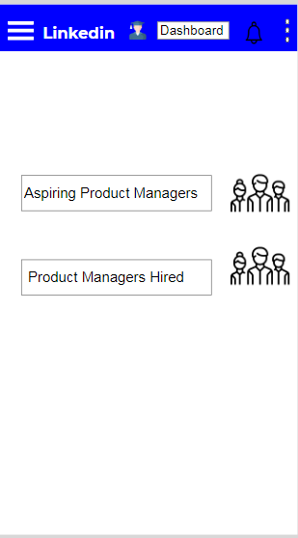

2. Skill Gap depicter < My Goals >

* This feature will allow users to find the current gap in their current skills and skills required in industry.
* This feature is accessible through home page of skills where we categorize skills based on three status: Acquired, in progress and not yet started.
* In the upcoming feature we will start showing jobs based on the skilled acquired.

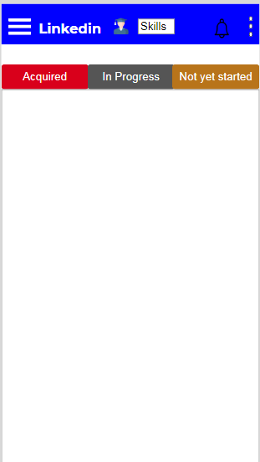

3. Group by

* This feature will allow users to group jobs based on industry or skill acquired.
* This feature is accessible from jobs page.
* In the upcoming feature, we will also start displaying jobs applied based on these filters.

